**HOTEL BOOKING MANAGEMENT**

END TERM REPORT

***By***

**MOHIT KUMAR MAHATO**

**SACHIN BAGHEL**

(Section: K19SB)

(Roll no. : 45, 54)



**Department of Intelligent Systems**

**School of Computer Science Engineering**

**Lovely Professional University, Jalandhar**

April-2020

**Student Declaration**

This is to declare that this report has been written by us. No part of the report is copied from other sources. All information included from other sources have been duly acknowledged. We aver that if any part of the report is found to be copied, we are shall take full responsibility for it.

Mohit Kumar Mahato

Roll no. – 45

Sachin Baghel

Roll no. – 54

Place – Lovely Professional University

Date – 9/4/2020

**TABLE OF CONTENTS**

**TITLE**  **Page No.**

1. **Background and Objectives of the project assigned…......... 5**
   1. **Description……………………………………………… 5**
   2. **Objectives……………………………………………….. 6**
   3. **Work Division…………………………………………... 6**
2. **Description of the project………………………………….... 7**
   1. **Modules…………………………………………………. 7**
   2. **Advantages……………………………………………… 8**
   3. **Limitations……………………………………………… 8**
   4. **Requirements…………………………………………… 9**
   5. **Pictorial flow of project………………………………... 10**
3. **Implementations of project………………………………….. 12**
   1. **Screenshots of website………………………………….. 12**
4. **Technologies and Framework to be used…………………... 16**
5. **SWOT analysis achieved in the project…………………….. 17**
6. **Project link…………………………………………………… 18**

BONAFIDE CERTIFICATE

Certified that this project report on“……….HOTEL BOOKING MANAGEMENT ……………..” is the bonafide work of “…………..MOHIT KUMAR MAHATO and SACHIN BAGHEL.…………” who carried out the project work under my supervision.

Name of supervisor - Dr. Dhanpratap Singh

ID of Supervisor - 25706

**BACKGROUND AND OBJECTIVES**

**Description:-**

Online hotel reservations are a popular method for booking hotel rooms. Travellers can book rooms on a computer by using online security to protect their privacy and financial information and by using several online travel agents to compare prices and facilities at different hotels.

Prior to the Internet, travellers could write, telephone the hotel directly, or use a travel agent to make a reservation. Nowadays, online travel agents have pictures of hotels and rooms, information on prices and deals, and even information on local resorts. Many also allow reviews of the traveller to be recorded with the online travel agent.

Online hotel reservations are also helpful for making last minute travel arrangements. Hotels may drop the price of a room if some rooms are still available. There are several websites that specialize in searches for deals on rooms.

An increasing number of hotels are building their own websites to allow them to market their hotels directly to consumers. Non-franchise chain hotels require a "booking engine" application to be attached to their website to permit people to book rooms in real time. One advantage of booking with the hotel directly is the use of the hotel's full cancellation policy as well as not needing a deposit in most situations. The online booking engine applications are supported by Content management system (CMS).

**Objective:-**

The objectives of an online hotel booking website are:-

* Provide people seeking hotel rooms with accurate information about available accommodations.
* Allow booking of rooms without errors and without creating conflicts.
* To present the hotel as an excellent, or the best, choice to its target market.
* To make it easy for customers to make reservations.
* To maximize occupancy
* To provide up to date information about the status of reservations

**Work division:-**

* Mohit Kumar Mahato:- Home page

Login pages

Booking portal

Bill payment portal

* Sachin Baghel:- About us page

Contact us page

Photos and icons

Hotel and room transition

**DESCRIPTION OF THE PROJECT**

As a description of this project and writing the procedure of it, we firstly done the research work of the code of this webpage, then finding the best interface of this webpage, the coloured background and best use of CSS on this.

Then we started writing the code by the help of some already made webpage’s codes. Then we changed it and developed our own. For writing the description, modules and contribution of us, we divided it into few parts. Our webpage have some limitations also which can be fixed and upgraded by using another languages and new data storing techniques and also for making it usable worldwide we can buy a domain and make it.

**Modules**:

In this web firstly we can see there are 6 options for a user-

• Home

• About us

• Contact us

• The hotel

• Rooms

• Login/ Logout

The website first authenticate the password whether it is correct or not in the sign up portal and if the password is not correct the user is given a notification to create a login id. If the user create the Id he is directed to the home page. Home page contains many other web pages linked to it like about us, Contact us, Help, Booking portal, Bill payment portal.

For home user can access the basic things of this webpage contents and get an easy and friendly interface of it.

For login user have to give his/her username and password and then login to his/her own account if the password is incorrect then automatically the sign up page opens.

The About us page gives the user brief knowledge about the hotel.

The Contact us portal helps the user to get the contact number of various staff with whom they can contact regarding any issue.

The booking portals allows user to enter necessary information for booking the desired room.

The bill payment portal helps the user to pay their bill online.

**Advantages:**

This webpage have very attracting and user friendly easy interface and have lots of advantages.

• Easy to access

• Colourful interface

• Easily understandable

• Many options

• Contact and About section

As previously mentioned our webpage have some limitations also like-

**Limitations:**

• Data storing issue

• Backend coding issue

• Can’t access by worldwide

• Not too much fast as compared to others

We believe that after getting know about other fast languages we can solve these issues also, for data storing we need our own server which don’t have right now, for backend coding need to apply new language and coding there, for world access we need domain.

**Requirement**:

For accessing this webpage and running it we need few things to do it-

• Any web browser

• Device that can run a web browser

• Internet connection (after getting worldwide)

For developing it we used-

• HTML

• CSS

• JAVASCRIPT

• NOTEPAD

• MS WORD

• GOOGLE CHROME

**PICTORAIL FLOW OF PROJECT**

Entering Password

CHECK

PASSWORD

(11901729)

Create Login ID

NO

YES

Home Page

About us

Contact us

Bill payment

Rooms

Hotel info

Bill payment portal

Detail filled

Complete details

NO

YES

Check out

Home

Logout

**SCREENSHOTS OF WEBSITE**

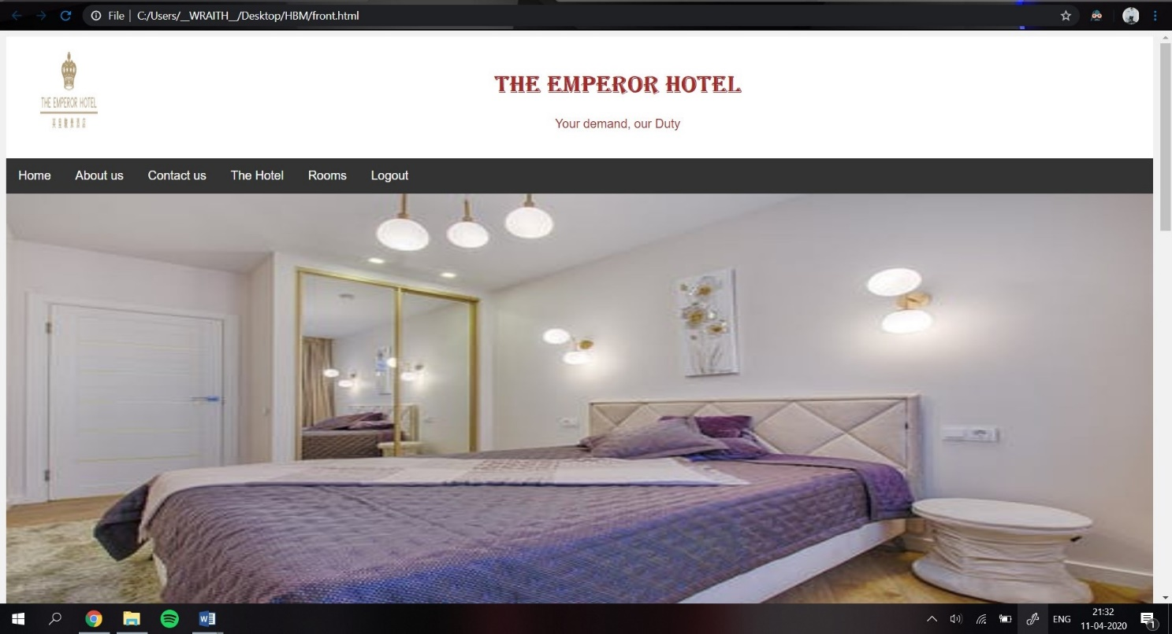Home Page

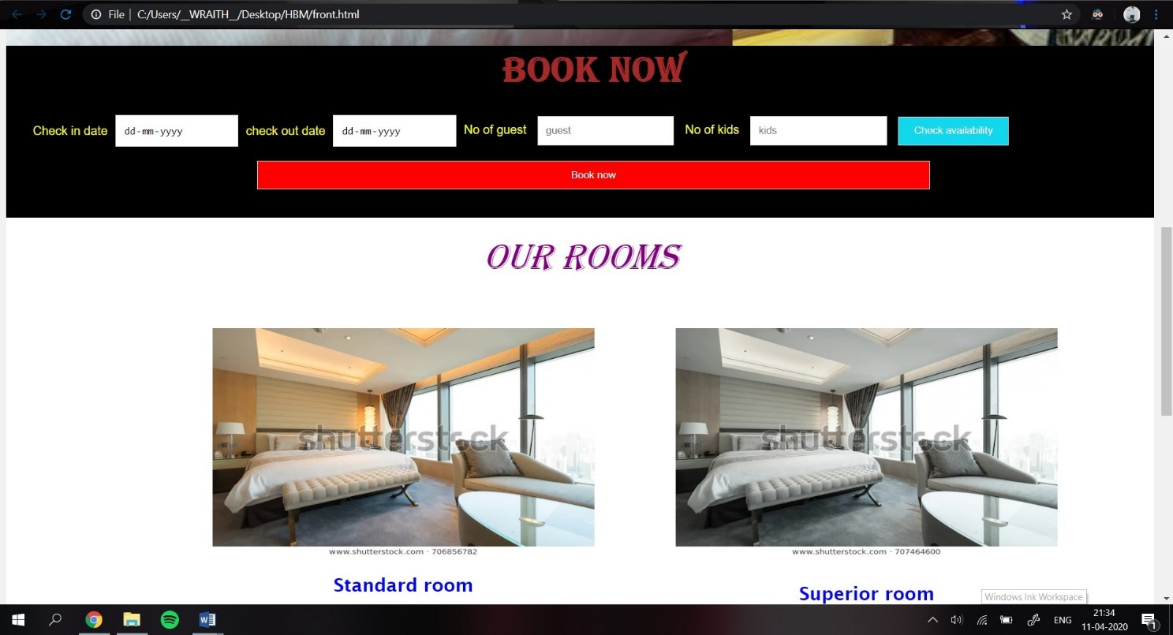Booking details and Rooms

Login page

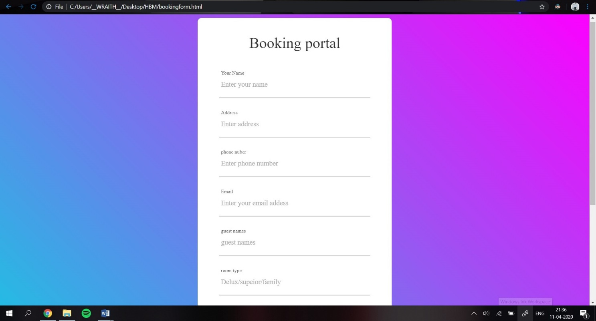

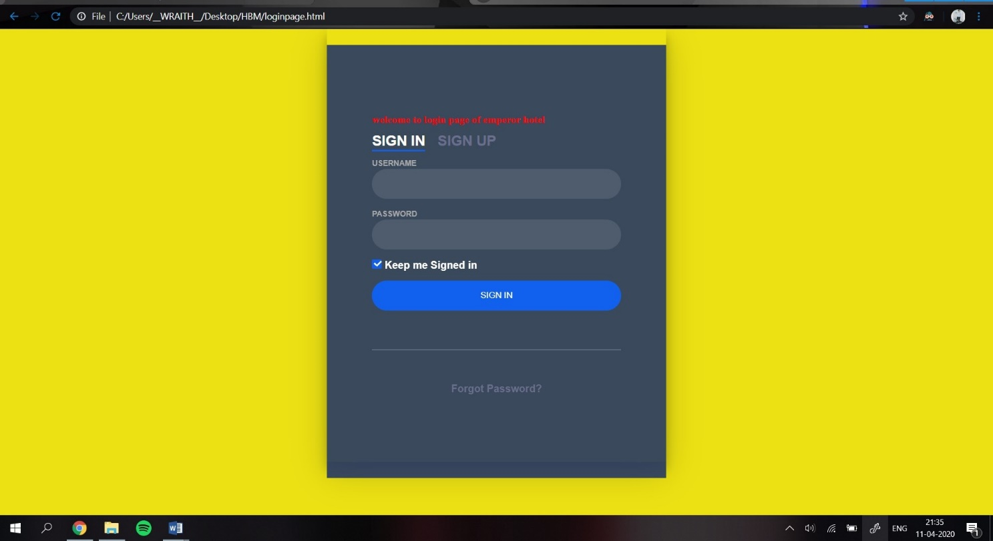Booking portal page

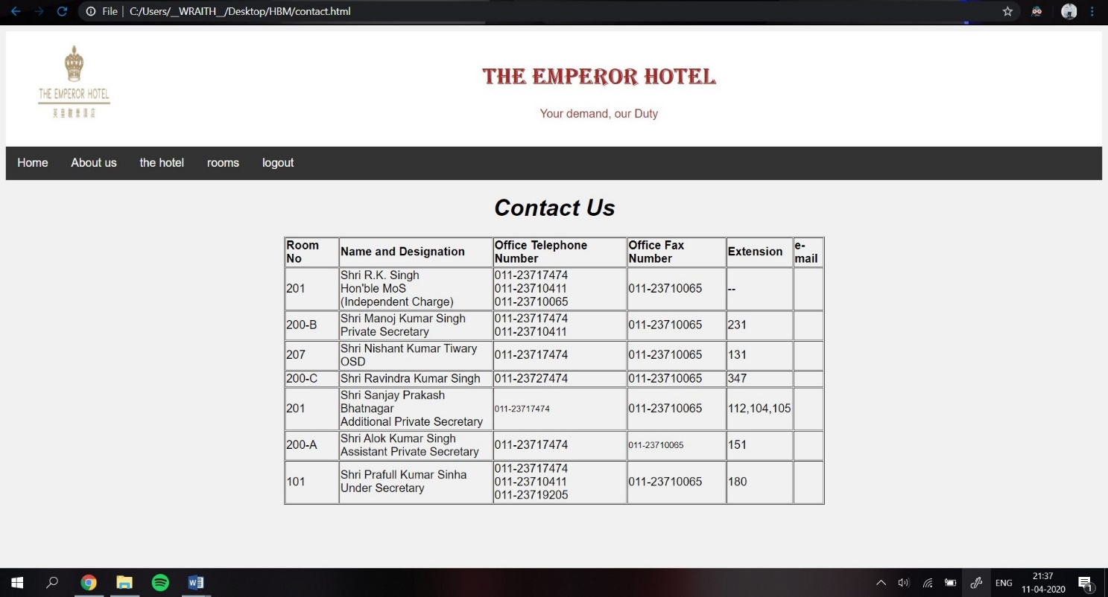Bill payment portal

Contact us page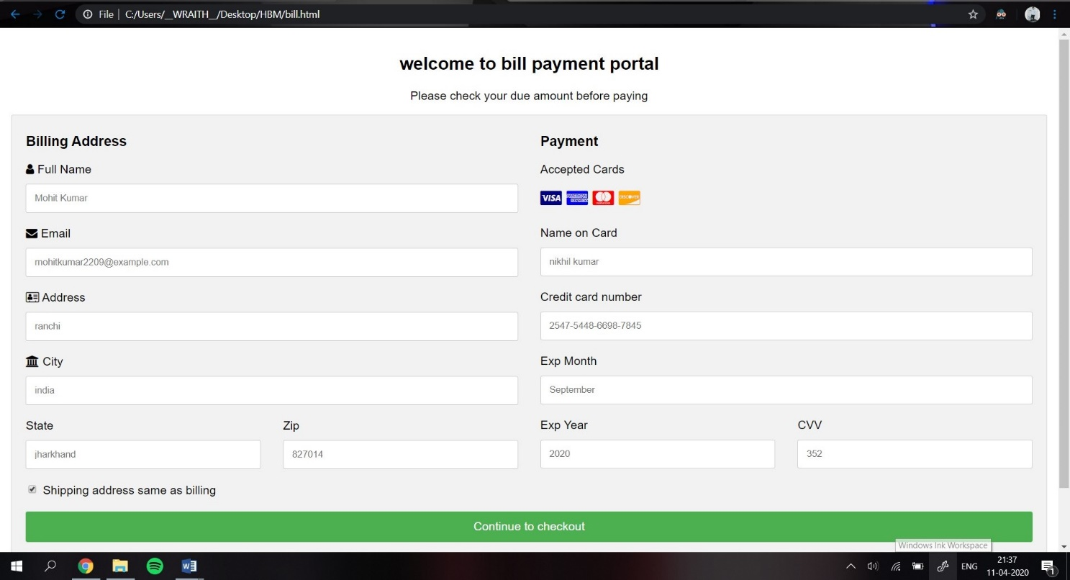

About us page

Sign up page

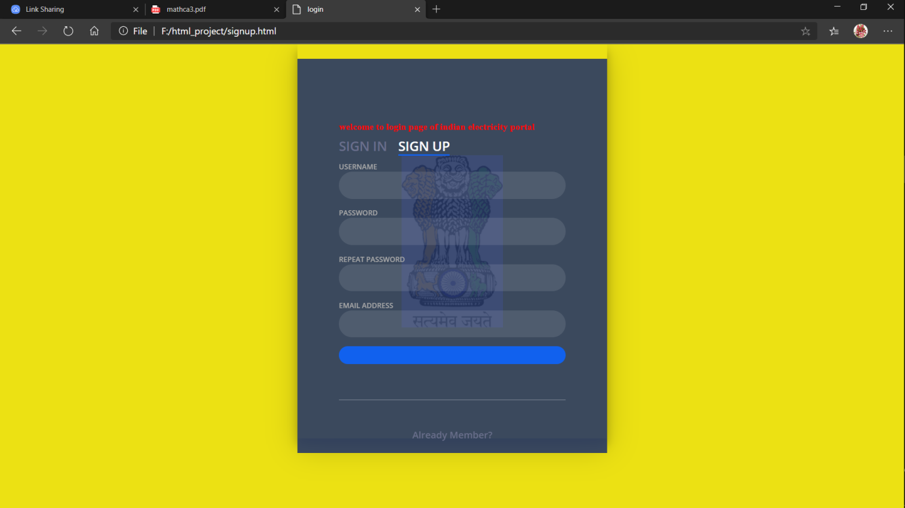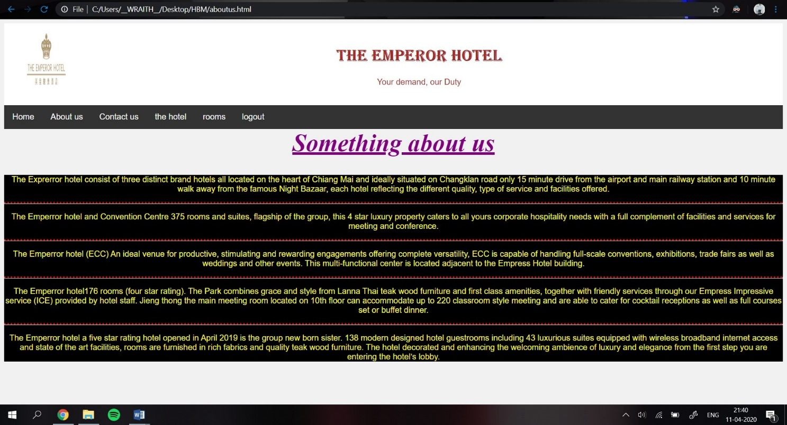

**TECHNOLOGIES AND FRAMEWORK TO BE USED**

We all three members tried our best to implement perfectly what we had learnt in our lectures and online tutorials. We had HTML, CSS and JAVASCRIPT in our project. We as a team coded our project in different modules. Initially we are facing to implement our ideas in coding but as time passes and we were learning from online platforms, our problem get resolved. And we were able to put our idea in coding format to build the best outcome that we can try at our level.

We had done of our coding in notepad platform.

**HTML:**

Hyper Text Markup Language is the standard language for creating documents for the World Wide Web. An HTML document is a text file, which contains the elements, in the form of tags that a web browser uses to display text, multimedia objects, and hyperlinks using HTML; we can format a document for display and add hyperlinks to other documents. The user interface has been designed in HTML hence can be browsed in any web browser.

**CASCADING STYLE SHEET (CSS):**

These have been used to separate data form presentation. By using these style sheets throughout the project, a uniform look and feel can be maintained for all the HTML elements and tags that have been used in the project. If there is any revamp the way the content has been presented in the website, the changes can be made to the appropriate style sheet, which will be reflected across all the style sheets.

**JAVA SCRIPT**:

JavaScript often abbreviated as JS, is a programming language that contains to the ECMASCRIPT specification. JavaScript is a high-level, often just-in-time compiled and multi-paradigm. It has curly -bracket syntax, dynamic typing, prototype-based object -orientation, and first-class functions.

**SWOT ANALYSIS ACHIEVED IN PROJECT**

**Strength**:

• Login / Signup pages

• Variety of rooms

• About us page which gives brief knowledge about the hotel.

• Contact us page for users to contact the customer care if they have any query or having problem in booking hotel rooms.

• Gallery section under the option Hotel so that the consumer can have an idea of the rooms they are booking.

• Book now section in home page where the user can provide check in and check out dates and the no. of guests.

• The booking portal where user can provide his/her personal information and move to the billing portal.

• The billing portal allows the user to pay the bill for the room where the user can use his/her card for payment.

**Weakness:**

• The system does not have back end or server side coding.

• There is no human interaction.

**Opportunities**:

• By making this online hotel booking website project we had learnt lots of thing which not only from technical aspect but also from ethical aspect.

• Importance of teamwork.

• With just completing our project we are not going to stop. In future we will develop many websites which can help our society.

**Threats:**

• Its not complete website of online hotel booking system.

• We lack in our backend part. Because at this time we do not have full knowledge of web development.